VINTAGE CASCAIS RUGBY 2013 PACKAGES

HOTEL ALVORADA***
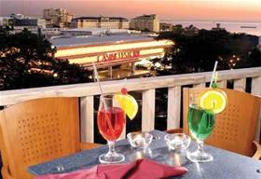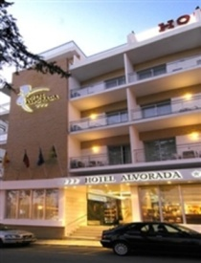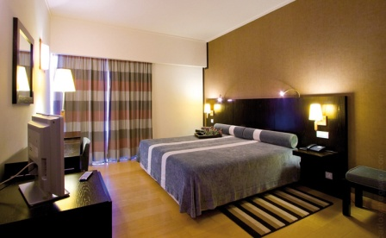
Recently renovated and upgraded, and conveniently located near the casino, beach, railway station and congress centre, the Hotel Alvorada is one of the best four-star properties in Estoril. Each of its 51 rooms has air-conditioning, central heating, phone, cable TV and safe-deposit box, while the hotel's facilities include a lavish buffet breakfast, the Cais do Estoril bar (open until midnight) and meeting rooms.

HOTEL LIDO***
Located in Estoril, 5 minutes from the beach and 20 minutes from Lisbon, the hotel offers 56 rooms and 6 junior suites, all with balcony, air-conditioning, radio, satellite TV, direct-dial phone and safe. Facilities include a panoramic restaurant with unique views over Estoril and the sea, bar with snacks, swimming pool with solarium, games room and parking. It was totally refurbished in 2004.


HOTEL SANA ESTORIL***
Located in Estoril, the hotel faces Estoril beach and offers a fantastic sea view of the Estoril Coast. 5 minutes walking distance to the Casino, Conference Centre, numerous bars, nightclubs and restaurants. With 97 rooms, accommodation with sea views, swimming pool, terrace bar, panoramic breakfast room and a pleasant, totally renovated lounge..
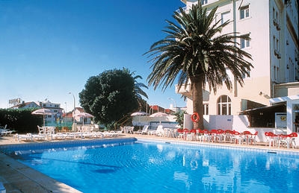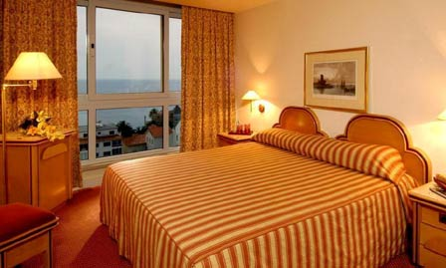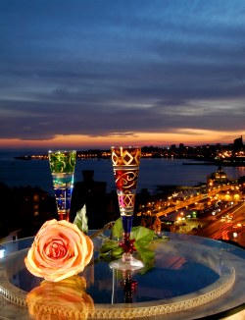

HOTEL PRAIA MAR****
Just by the largest sandy beach of the Estoril Coast – Carcavelos – the Praia-Mar Hotel has a magnificent ocean-front view. It offers the very best in Portuguese cuisine and remains a popular place for social events and fine banquets. Convenient location, exceptional service and quality facilities also make it ideal for conferences and meetings. Outdoor swimming pool, easy and quick beach access, gardens and private parking are waiting for you.

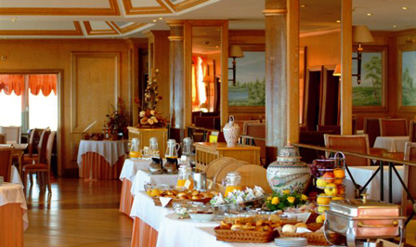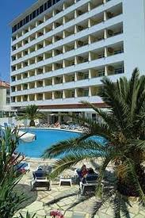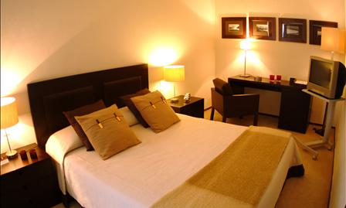

∞/∞

Hotels Price List & Packages Price List (Individual Festival Application + Accommodation)

 |  |  |  |  | Prices /Night (Room) |  |  | HOTEL + FESTIVAL PACKAGES (per person)
Hotel | Stars | Local | Observations |  | Single | Twin |  | 2 NIGHTS | 3 NIGHTS | 4 NIGHTS
Hotel São Mamede | 2 | Estoril | PARTNER HOTEL |  | 46,00 € | 56,00 € |  | 104,00 € | 131,00 € | 158,00 €
Hotel Alvorada | 3 | Estoril | Few Rooms left |  | 55,00 € | 67,00 € |  | 115,00 € | 147,50 € | 180,00 €
Hotel Londres | 3 | Estoril |  |  | 80,00 € | 84,00 € |  | 132,00 € | 173,00 € | 214,00 €
Hotel Baía | 3 | Cascais | Land View |  | 88,00 € | 109,00 € |  | 157,00 € | 210,50 € | 264,00 €
Hotel Sabóia | 3 | Monte Estoril | Few Rooms left |  | 86,00 € | 92,00 € |  | 140,00 € | 185,00 € | 230,00 €
Hotel Sana Estoril | 3 | Estoril | PARTNER HOTEL |  | 66,00 € | 72,00 € |  | 120,00 € | 155,00 € | 190,00 €
Hotel Lido | 3 | Estoril | PARTNER HOTEL |  | 65,00 € | 77,00 € |  | 125,00 € | 162,50 € | 200,00 €
Hotel Inglaterra | 4 | Estoril |  |  | 123,00 € | 123,00 € |  | 171,00 € | 231,50 € | 292,00 €
Hotel Riviera | 4 | Carcavelos |  |  | 107,00 € | 118,00 € |  | 166,00 € | 224,00 € | 282,00 €
Hotel Praia Mar | 4 | Carcavelos | PARTNER HOTEL |  | 61,00 € | 67,00 € |  | 115,00 € | 147,50 € | 180,00 €

The VINTAGE CASCAIS RUGBY PACKAGES are designed for teams with more than 20 players and include:
- Festival Participation, Games
- The chosen Number of nights’ accommodation with Bed and Breakfast Buffet.
- Free admission for all activities at the Festival venue
- Rugby Festival Gala Dinner (Saturday Night)

Important Notes:
- Prices indicated based on a minimum of 20 persons travelling
- Prices indicated based on accommodation with double occupancy minimum. Single occupancy will be quoted on request.

- Bus transfers from/to Lisbon International Airport & to/from Festival Venue may be quoted under request.
  - Prices vary with the number of participants per team. Estimate: Every transfer = 200,00€ per way.

